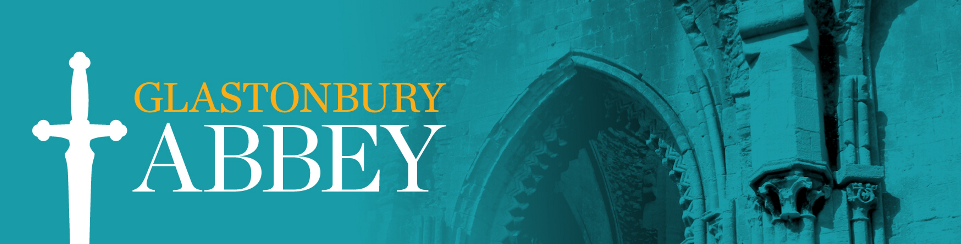

Fair Processing Notice for Mobile App

At Glastonbury Abbey, we respect your personal data. This Fair Processing Notice explains how we will use your personal data when you download and use our mobile apps. Your information will be filed securely both on our computers and any paper copies will be securely stored.

Our contact details

Glastonbury Abbey
Magdalene Street
Glastonbury
Somerset
BA6 9EL
01458 832267

What personal data do we collect about you? How will we use that personal data?
When you use our app, you may give us information directly (if contacting our support email), and we’ll store that information on our systems and use it for the purposes described in this Privacy Policy. Some limited information is also collected automatically for analytics purposes.
When you use our mobile app, we will collect the following personal data about you with consent:
- IP Address/ MAC address when you use the app
- Camera Our app may request permission to use your camera and local storage for the purpose of viewing augmented reality content, capturing photos or recording videos, and saving photos or videos to your device. Any images or videos you capture are only stored locally on your device and will never be transmitted to us or any other third party by any of our apps.
- Motion and Orientation
- Geolocation data
- Limited analytic data
- Push notifications
This data is required in order for the app to function. However, permission can be revoked at any time via the settings in your device rather than the app itself. If the user is under 13 years old, permission from a parent/guardian will be requested.
If contacting us via email with enquiries about the app or general enquiries, we will record the data you provide us with in order to deal with your request. This may include but not be limited to: name, email address, and telephone number.

What is our legal basis for processing your personal data? How long do we hold your personal data?
We need a legal basis in order to process your personal data.
- We need your name and contact details in order to answer your enquiry and we process this data with your consent.
- We collect geolocation data and camera, motion and orientation functions with your consent to ensure our app works as intended on your device and as necessary to provide the content or services you request on our app.
- We process your IP address and MAC address so that we can monitor the use of our app, this is a legitimate interest for a business.
- We will send you marketing information and newsletters when you consent for us to do so. You have the right to unsubscribe to marketing at any time by disabling notifications.

Do we have a statutory or contractual requirement to process your personal data?

There is no contractual requirement for us to process your personal data.

Do we use any automated decision making?
We do not use any automated decision making.

Who do we share your personal data with?

- Companies that provide services to us. Our telephone service providers will get to see your phone number if we call you and our broadband supplier which could see your email address (but not the content of what you send us, if you encrypt it).
- Cloud service & IT providers. We use a number of cloud service & IT providers, such as our CRM, project management systems and webhosting. We also share with IT professionals who not only ensure that our systems run smoothly, but are also committed to the highest standards of data protection compliance.
- We use Square to process payments from our website.
- We use a Bookkeeper and an Accountant to help us with our finances.
- In response to a court order. It is possible, though unlikely, that we might be forced to disclose your information in response to a court order.
- We use a marketing consultancy and an email service so that we can update you with our news and events.

Do we transfer your personal data outside of the EU or EEA?

We use Microsoft, Google, Square, Quickbooks, Clickup, Surveymonkey, Zoom and DropBox, which are based in the USA. Safeguards for the use of these companies are built into the companies’ Standard Contractual Clauses (SCCs).

How long do we keep your personal data for?

- We will only retain your personal information for as long as necessary to fulfil the purposes we collected it for, including for the purposes of satisfying any legal, accounting, or reporting requirements.
- To determine the appropriate retention period for personal information, we consider the amount, nature, and sensitivity of the personal information, the potential risk of harm from unauthorised use or disclosure of your personal information, the purposes for which we process your personal information and whether we can achieve those purposes through other means, and the applicable legal requirements.
- In some circumstances we may anonymise your personal information (so that it can no longer be associated with you) for research or statistical purposes, in which case we may use this information indefinitely without further notice to you.
- If you purchase goods or services from us, we will keep your data for 6 years.
- If you make an enquiry, we will keep your data for a maximum of 18 months after your enquiry is resolved.
- If you are on our email marketing list, you are welcome to unsubscribe at any time, but we will keep your personal data in a suppression list so that we don’t email you again by accident.

Your rights as a data subject
The GDPR gives you rights as a data subject. You have:
1. the right to request from us access to your personal data;
2. the right to request from us rectification of your personal data;
3. the right to request from us erasure of your personal data;
4. the right to request from us restriction of processing your personal data;
5. the right to object to our processing of your personal data;
6. the right of data portability;
7. if we are processing your personal data on the basis of your consent, you have the right to withdraw your consent at any time. This does not affect the lawfulness of processing based on your consent before you withdrew it; and
8. You have the right to complain to the ICO.
More information on your rights can be found in Chapter 3 of the GDPR.

Updated January 2023

