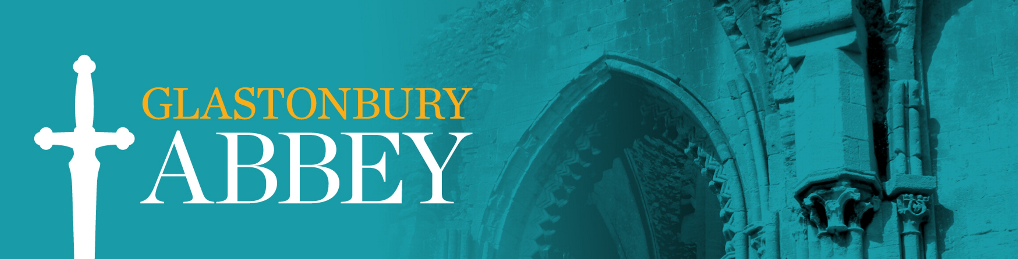

Fair Processing Notice for School Visitors

At Glastonbury Abbey, we respect your personal data. This Fair Processing Notice explains how we will use your personal data when you arrange a school visit at Glastonbury Abbey. Your information will be filed securely both on our computers and any paper copies will be securely stored.

Our contact details

Glastonbury Abbey
Magdalene Street
Glastonbury
Somerset
BA6 9EL
01458 832267

What personal data do we collect about you?

When you arrange a visit for your class we will collect and process your name and email address, details about your visit and payment information.

How will we use that personal data? What is our legal basis for processing your personal data?
We need a legal basis in order to process your personal data.
- We need your name, contact details and payment details in order to arrange your visit to Glastonbury Abbey so we can fulfil our contract to you.

Do we have a statutory or contractual requirement to process your personal data?

There is a contractual requirement for us to process your personal data if you are one of our school visitors as we wish to fulfil our contractual responsibilities.

Do we use any automated decision making?
We do not use any automated decision making.

Who do we share your personal data with?

- Companies that provide services to us. Our telephone service providers will get to see your phone number if we call you and our broadband supplier which could see your email address (but not the content of what you send us, if you encrypt it).
- Cloud service & IT providers. We use a number of cloud service & IT providers, such as our CRM, project management systems and webhosting. We also share with IT professionals who not only ensure that our systems run smoothly, but are also committed to the highest standards of data protection compliance.
- We either invoice your school or use Square and World Pay to process payments.
- We use finance department and an Accountant to help us with our finances.
- In response to a court order. It is possible, though unlikely, that we might be forced to disclose your information in response to a court order.

Do we transfer your personal data outside of the EU or EEA?

We use Microsoft, Google, Square, Quickbooks, Clickup, Survey Monkey, Zoom and DropBox, which are based in the USA. Safeguards for the use of these companies are built into the companies’ Standard Contractual Clauses (SCCs).

How long do we keep your personal data for?

- When you visit Glastonbury Abbey we will keep your personal data on file for one year following your visit.
- We will keep details of payment on our accounting for 7 years.

Your rights as a data subject
The GDPR gives you rights as a data subject. You have:
1. the right to request from us access to your personal data;
2. the right to request from us rectification of your personal data;
3. the right to request from us erasure of your personal data;
4. the right to request from us restriction of processing your personal data;
5. the right to object to our processing of your personal data;
6. the right of data portability;
7. if we are processing your personal data on the basis of your consent, you have the right to withdraw your consent at any time. This does not affect the lawfulness of processing based on your consent before you withdrew it; and
8. You have the right to complain to the ICO.
More information on your rights can be found in Chapter 3 of the GDPR.

Updated July 2022

